CS 255 System Design Document Template

This template lays out all the different sections that you need to complete for Project Two. Each section has guidance to prompt your thinking. You will need to continually reference the interview transcript as you work to make sure that you are addressing your client’s needs. There is no required length for the final document. Instead the goal is to complete each section based on what your client’s needs are. Remove this note when you are finished, and replace all bracketed text with the relevant information.

UML Diagrams

UML Use Case Diagram
This Diagrams shows how customers, the secretary, drivers, the owner, the IT officer, and the DMV interact with DriverPass. Customers manage accounts, select packages, access training, and schedule lessons. Staff assist with customer records and appointments, drivers enter lesson notes, the owner reviews reports and packages, and the IT officer manages accounts and access.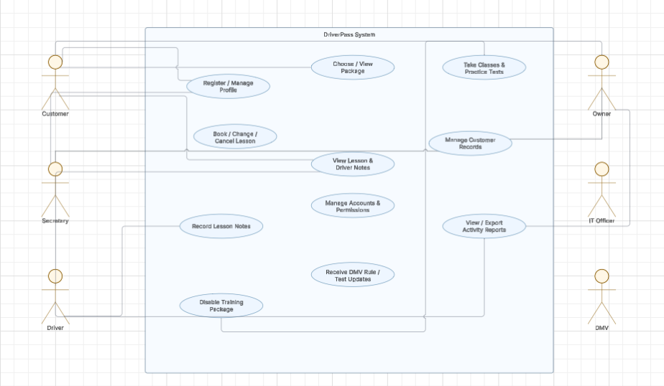

UML Activity Diagrams
The first activity diagram follows customer registration and training-package selection. The second follows scheduling a driving lesson, including checking driver and vehicle availability, offering another time if the requested slot is unavailable, and confirming the reservation when it is saved.

UML Activity Diagram 1 – Schedule a Diving Lesson
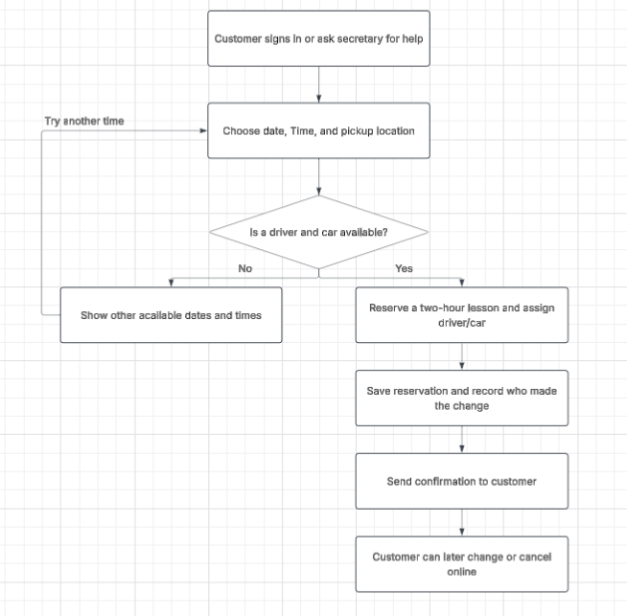
UML Activity Diagram 2 – Register and Select Training Package
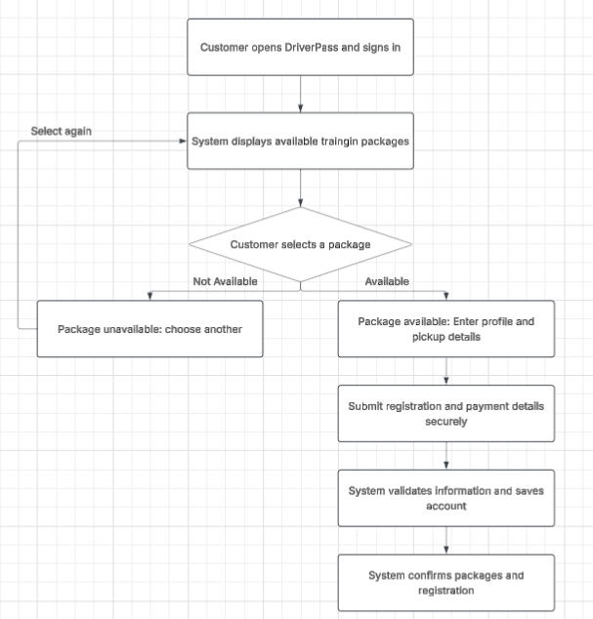

UML Sequence Diagram
The sequence diagram follows a lesson booking from the customer’s request through the website and reservation service. The system checks availability, saves the appointment, records the action, and returns a confirmation or suggests another time.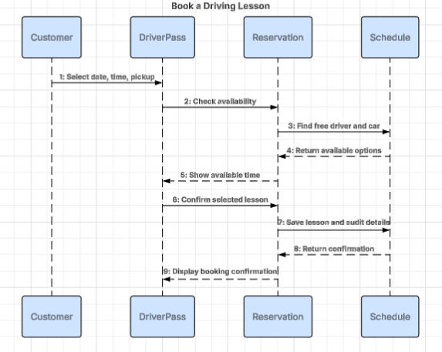

UML Class Diagram
The class diagram identifies the main records the system needs, including user accounts, customers, training packages, reservations, drivers, vehicles, practice tests, driver notes, and activity logs. Their attributes describe the information to be stored and the relationships between records.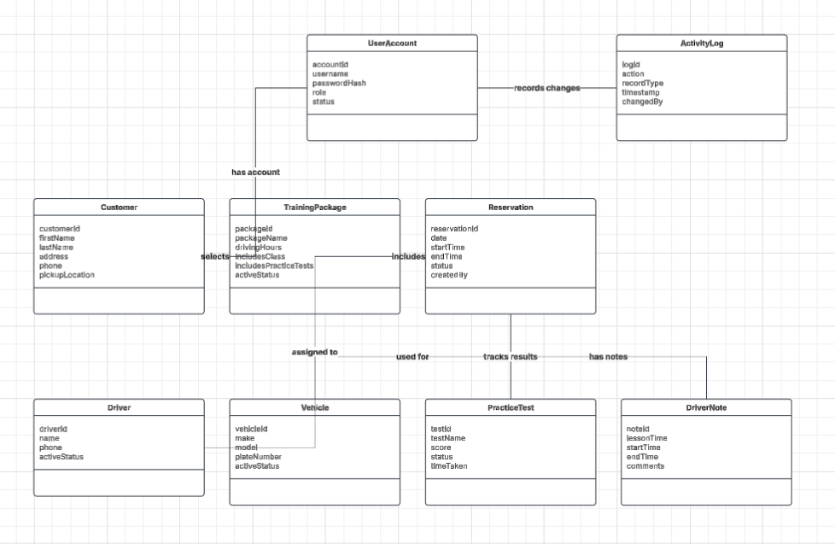

Technical Requirements
The proposed system is a cloud-hosted web application. The following requirements describe the hardware, software, development tools, infrastructure, and safeguards needed for the design.
Hardware
Customer and employee devices: desktop and laptop computers, tablets, and smartphones with a supported browser and internet access.
Business equipment: employee workstations and a reliable internet connection. A local server is not required for the proposed cloud-hosted design.
Hosting resources: cloud application hosting, managed database storage, and secure backup storage sized for customer records, reservations, and training content.
Software and tools
A responsive web application that works in current desktop and mobile browsers.
A relational database to store customer details, packages, reservations, driver and vehicle assignments, test results, lesson notes, and activity logs.
Secure sign-in, password reset, role-based permissions, reporting/export features, and a way to receive or apply DMV rule and practice-question updates.
Lucidchart or a similar UML tool for maintaining diagrams, plus standard development, testing, and version-control tools during implementation.
Infrastructure and security
Use HTTPS to protect information sent between users’ devices and the website.
Store passwords using secure password hashing rather than readable passwords and limit screens and actions according to each person’s role.
Use a suitable payment provider and avoid storing payment-card details unnecessarily. The exact provider and compliance requirements must be confirmed before development.
Enable automated backups, monitoring, security updates, and a tested recovery process through the hosting provider.
Keep a record of important reservation and account actions, including who made the change and when.
An internet connection is required to create or change shared records. Any offline access in the first release should be read-only.
Functional requirements
FR-1: Customers can create or access an account and maintain contact and pickup information.
FR-2: Customers can view active training packages; authorized staff can disable packages from new registrations.
FR-3: Customers can access online classes and practice tests included with their package and review relevant progress and scores.
FR-4: Customers can book, change, or cancel two-hour driving lessons online.
FR-5: The secretary can register customers and schedule or change appointments on their behalf.
FR-6: Each reservation is associated with a customer, date, time, driver, and vehicle; conflicting assignments are prevented.
FR-7: Drivers can record lesson times and comments.
FR-8: Authorized staff can review and export reports showing important reservation activity.
FR-9: The IT officer can reset accounts and block access when needed.
FR-10: The system supports applying DMV rule, policy, and sample-question updates and notifying relevant staff.
Nonfunctional requirements
Security: Personal information and account access are protected through encrypted connections, role-based access, and secure password handling.
Usability: Clear labels and straightforward steps help customers and employees use the system without specialized technical knowledge.
Availability and recovery: Cloud hosting and automated backups reduce disruption and data loss, subject to provider availability.
Accountability: Important reservation and account changes are recorded with the user and timestamp.
Maintainability: Customer, package, reservation, training, and audit information are separated into logical records so changes can be tested and maintained.
Assumptions and limitations
The design assumes users have internet access for changes to shared information; offline updates are not supported in the initial version.
The owner can disable a package, but new package types or major system features may require developer support.
Automatic DMV updates depend on an approved data feed, API, or another agreed method. The interview does not specify the technical connection.
The payment provider, refund process, data-retention period, hosting provider, and recovery targets must be confirmed with DriverPass before implementation.

